Tweedie distribution

Def

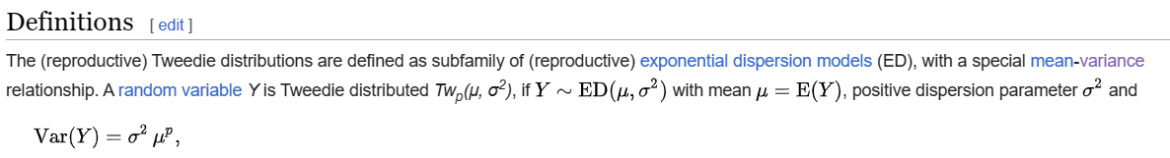

$$Var\left(Y\right)$$ = $$std{\left(Y\right)}^{2}⋅E{\left[Y\right]}^{p}$$

PDF

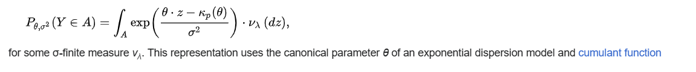

CDF

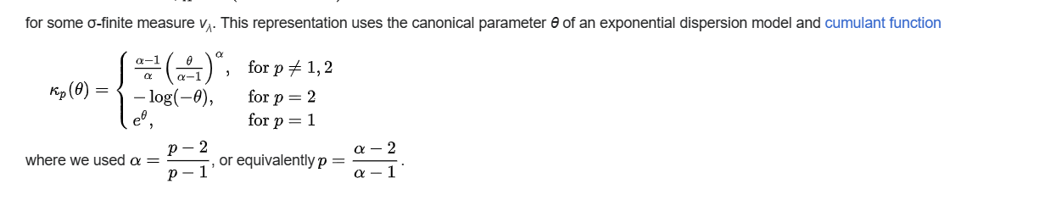

Property

Additive exponential dispersion models

If $$Y$$ is reproductive,

then

$$Z$$ = $$l⋅Y$$

where $$l$$ = $$\frac{1}{disp^{2}}$$

is in additive form $$ED^{⋅}\left(theta,l\right)$$ for Tweedle $$Tw_{p}^{⋅}\left(E\left[Y\right],l\right)$$

Suppose

$$Z_{+}∼ED^{⋅}\left(theta_{i},l_{i}\right)$$

with fixed $$theta$$ and various $$l$$ are members of the family of distribution with same ,

and $$Z_{1},…,Z_{n}$$ be independent random variables,

then random variable of additive model is the sum of each independent random variables

$$Z_{+}$$ = $$Z_{1}+…+Z_{n}$$

$$Z_{+}$$ is also an independent random variable.

Reproductive exponential dispersion models

$$Y$$ = $$\frac{Z}{l}∼ED\left(E\left[Y\right],disp^{2}\right)$$

where

$$disp^{2}$$ = $$\frac{1}{l}$$

Given:

Weighting factor $$w_{1},…,w_{n}$$

and $$n$$ independent random variables $$Y_{i}∼ED\left(E\left[Y\right],\frac{disp^{2}}{w_{i}}\right)$$

Suppose:

$$w$$ == $$sigma\left(w_{i},i=1,i=n\right)$$

Then:

A weighted average of the variables get:

$$\left[\frac{sigma\left(w_{i}⋅Y_{i},i=1,i=n\right)}{w}\right]∼ED\left(E\left[Y\right],\frac{disp^{2}}{w}\right)$$

The Tweedie exponential dispersion models are both additive and reproductive; we thus have the duality transformation.



Ref

[Tweedie distribution - Wikipedia](https://en.wikipedia.org/wiki/Tweedie_distribution)